TTRB Spring Workshops 2006
Working with Windows Moviemaker
This handout is to be used in conjunction with the session on Audio-Visual Materials
Purpose: | This training pack has been written In order to maximise the potential of the TTRB to deliver usable pieces of video text direct from the website or from the Teachers’ TV website itself. It is based on using Windows Moviemaker as the default standard video-editing software available on all Windows driven PCs. For Apple Macintosh users a similar product called iMovie is available and there is a vast range of other bespoke products for more advanced or e-confident users of ICT.  Having worked through the pack users will be able to:  - locate digital video files that will be of use to them in their context  - download such files to a local PC, laptop or LAN connected computer  - edit and re-purpose these files for use in their own setting  - produce learning and teaching materials enriched with digital media
Getting Started  Windows Moviemaker is a piece of software that comes bundled together in the Windows XP (Home or Professional operating system). It is a surprisingly powerful tool for something that is essentially a ‘give away’. To find the program you will need to click start and then look in the accessories menu. As highlighted in Figure 1.  Summary:  Click <Start>  Click <Accessories>  Click <Windows Moviemaker>  When you perform this action you will arrive at an open desktop. You should consider this to be just like a word processor package with which you are familiar. It has all the same commands and instructions – the difference is that you will be working with video text and not words. So - <File> will allow you to open a new project or digital video saved on your machine. It will enable you to save any new project you are creating or indeed it will allow you to exit from the program. Similarly you will find commands like <help> (Which you can also access by pushing F1) or <edit>. | 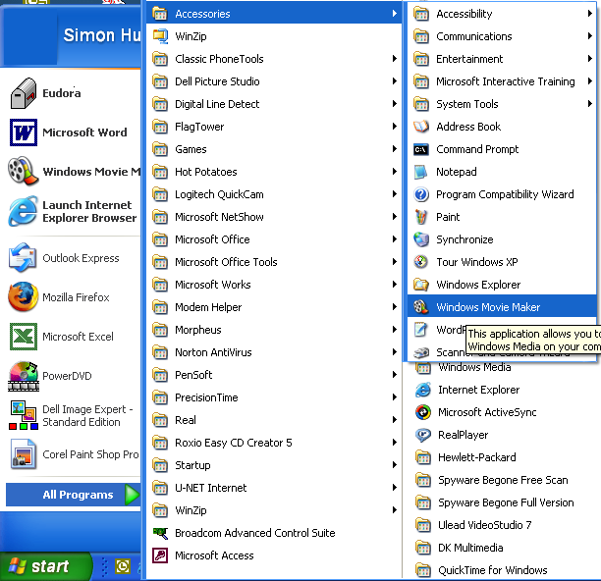  Figure 1: The Start Menu
File Management | Working with Windows Moviemaker requires a person to be more confident and careful in their handling of data. You are advised strongly to undertake the following steps to ensure you do not lose any data and that you can easily retrieve the movie you are about to make.  You should create a folder into which you are going to put the contents of the ‘project’ on which you are about to embark. The most logical place to do this is in the ‘My videos’ folder which can be accessed through ‘My Computer’.

9 Quick Steps to Creating a Project Folder:  - Click <Start>  - Click <My Computer>  - Click <My Documents>  - Click <My Videos>  Once inside this folder you will need to create a new one for the current project. It is advisable to give it a date as well as a name.  - Double click <My Videos>  - Right click on a clear space inside the folder  - Select <New>  - Click <Folder> – top of the list  - Name the Folder e.g. project#1_060205  Push <enter – return> and you will have created a new target folder for all your work. Make a note of this; you will come back to it several times in the process. | 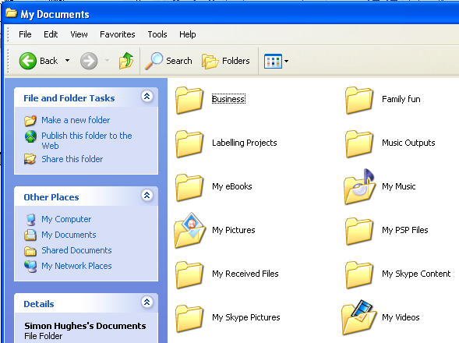  Figure 2: My Videos
1. Selecting Useful Video Material
3 Ways to find digital video materials  - Browse the web  - Go direct to the Teachers’ TV website www.teachers.tv  - Search the TTRB archive | There are several ways in which you can access digital video material for use in in initial teacher education. The TTRB team recommend that you select materials that have been assessed already in terms of quality and reusablility. This means that it is adivisable to undertake a search on the TTRB using the keyword ‘video’. Alternatively you can browse the video archive which is reached through the <research and resources> button. Look at Figure 3 below to see how you might reach this archive from the TTRB homepage.
Find the research and resources button  Browse the types of resource field  Select the Video recording button |   Figure 3: TTRB Video archive
Downloading digital video | Once you have selected some digital video that you think will be of use to you in your work it is a good idea to download it in order to be able to manipulate it for your own purposes.
Dos and Don’ts in DV downloading | Dos  Do make sure you have sufficient diskspace on your computer, flash drive or network to save the file – You can tell how big it is by holding the mouse over the link.  Do decide where you want to store the file and control the computer  Do ensure you have software installed that can playback digital video |  | Don’ts  Don’t attempt to download digital video using a 56k modem – It will take too long  Don’t allow the computer to dictate where you will store the video  Don’t click download and walk away – you need to watch what is happening!
Recommendation | It is advisable to have installed the latest version of Windows Media Player installed on your computer. At the time of writing the current version is number 10. You can access this as a freedownload from the Windows Update website http://update.microsoft.com/microsoftupdate/v6/default.aspx?ln=en-us
Some extra tips  4 steps to downloading Teachers’ TV  - Select the video you wish to use  - Right click on the option you need – broadband or dialup  - Select the folder you created for your project  - Rename the file to something you recognise and away from Teachers’ TV’s own coding | Teachers’ TV allows you to download their programmes free of charge to watch them on a Computer as if it were a TV. To do this all you need to do is press the relevant download button for your system. Of course you could watch the programme on a traditional TV getting the programmes through a cable or freeview set top box.  If, however, you wish to save the programme for use later you will need to record it using an analogue video recorder, a hard disk recorder (hdd recorder), a dvd recorder or by saving it to a computer’s memory.  Here the focus is on this latter method of data storage.  Teachers’ TV allows you to download and save its programmes from the website. Follow the steps under ‘extra tips’
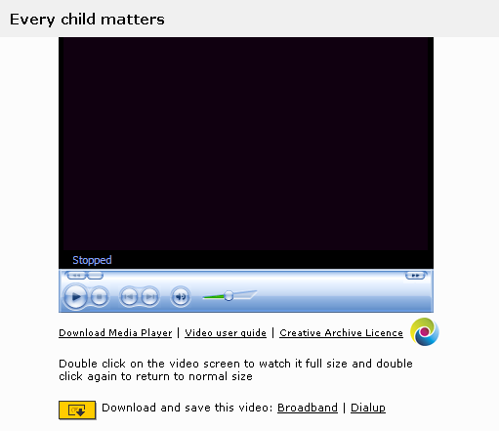  NB: You will need to be registered with Teachers’ TV in order to download resources  Figure 4: Teachers' TV Download site |  | To the left is a sample screen of the download site for Teachers’ TV. Notice:  - the Download Media Player button – useful if your machine does not have Windows Media Player 10 installed  - the choice between broadband and dialup  - the Video User Guide  Notice that you can also watch the programme on your PC direct from the web. It is not necessary to save the video before you watch it which means you can save on memory.  Saving the video means that you can do much more with it as will be seen in the next section.
2. Working with Digital Video | Having saved some data you are now in position to use it. In this section instructions are offered that will enable you to re-purpose the material for use in your own ITE work.
Windows Moviemaker    Figure 5: WMM icon | Here’s a test! See if you can re-locate Windows Moviemaker using the instructions on the first page of this booklet. You may even find that it has been ‘pinned’ to the start menu for the computer you are using. Try clicking <start> (Bottom left hand corner of the screen).

Importing Video  Summary actions:  Click <import video>  Select <Every Child Matters> from the place where you stored it>  OR  <Repeat> this process for any programme you have selected during today’s session | Before working on a video to select the clips you want you need to import the file into the software. Teachers’ TV has already done a lot of the hard work for you in this area since their programmes are already saved in Windows Media Audio/Video format – Look for the suffix .wmv after an alphanumeric filename.  The programme in focus in this workshop is presented to you as Every Child Matters. On the website it is listed as CO458001_340K.wmv. This is its filename. You may prefer to change this when you have downloaded the file so that it is more easily recognisable in your own filing system. If you are importing the video from a VCR you will also need to give it a filename.  The commands for importing video (and audio) are found in the left hand pane on the editing window. Use the simple instructions in the left hand column of this guide to complete this stage if the task.
Handling video clips | If you completed the first step accurately you will end up with a new folder containing a number of video clips. Windows Moviemaker ‘chunks’ this sort of file into segments that can be more easily manipulated. See how this appears in Figure 6 below:  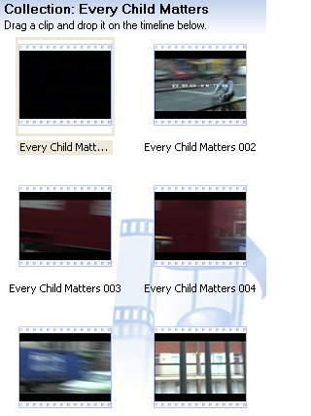  Figure 6: Collections menu
Dragging and dropping to the Timeline | The next step is to be able to watch the video through to ensure you have what you want.  Step 1 – Click <edit>, click <select all>, drag the blue highlighted squares to the timeline you can see at the bottom of the screen.
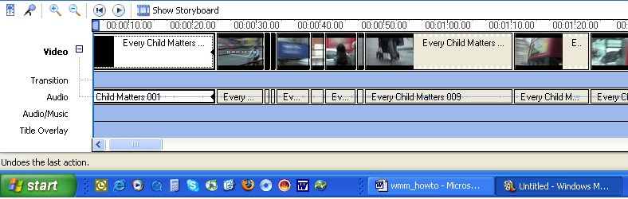
 | You should end up with something that looks like this. Notice this window in the status bar. This is telling us that although we have already undertaken quite a lot of work we have not yet saved it. It is important to remember that although the original file will not be changed by what you have done, the new ‘project’ has not yet been saved and you should do so now before losing any work.
Saving the Project | Step 2 – Saving the project. Please note this will not be the final product of this session.  Click <File>, click <Save project as>  Remember to:  - Save the project in the same place as the movie file with which you are working  - Save the project with a name that you will be able to remember easily  - This is not your finished product.
3. Editing the Project | Now it’s over to you. From this point on there are a number of things you could do.  - Select only those clips you wish to take away for use  - Join together the relevant sections you wish to use into one new product  - Select and save various sub-sections of clips  - Add your own titles or commentaries to your project
Selecting clips | Using the scroll bar at the bottom of the timeline window, move through the project identifying those chunks that will be most of use to you.  De-select the bits that are irrelevant by right-clicking on them and choosing delete
Joining clips | Once you have de-selected the bits you do not want Windows Moviemaker will automatically join up the remainder.  Alternatively you could abandon the timeline and only drag and drop those clips from the collections folder that meet your requirements. In effect you would be starting again. To empty the timeline hold down <shift>, scroll to the end of the line, <highlight> the last clip and press <del>.  Don’t for get your undo button: It’s very useful at times like this!  Advanced or e-confident users might wish to select clips, copy them and paste them onto a new time line in a new project.
Selecting sub-clips | Find the clip you want – hold the cursor over the ‘split clip’ button on the right hand side of the playback window and <clip> when you get to the piece of video you want. Repeat the process at the end of the required section. Drag and drop this new clip to a new project or strip away everything from either side of it.
Taking snap shots | Find the clip you want – hold the cursor over the camera button on the right hand side of the playback window and <snap> when you get to the frame you wish to use as a still. Here’s one that was prepared earlier:  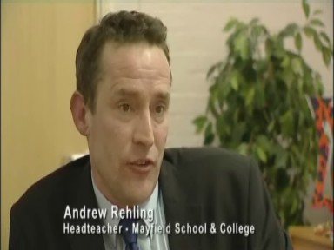  Figure 7: Still from ECM programme
Adding titles or commentaries | It is unlikely that there will be sufficient time for this activity in the course of the workshop but it is worth having a play with the idea when you get time. Follow the on-screen instructions which are in the 2nd section of the left hand pane. If you have used Powerpoint before you will not find this difficult since it deploys much of the same functionality as you will be used to in that program.  Experiment with adding titles at the beginning to introduce the learning intentions you have for showing a particular clip; add titles to a clip to focus the minds of your audience; acknowledge the work of the participants at the end of a segment if that fits. The only limit here is your imagination.

4. Rendering the Project | Once you have completed your editing you will need to ‘finish’ the movie. This is the term that Microsoft applies to creating a finished product. Other software applications refer to this as ‘rendering’.  Rendering is the process of ‘gluing’ all the artefacts, objects, resources, transitions, actions, images and sounds gathered into the project into one coherent movie. This is really important because without this stage of the process the movie will only work in this editing window.  ALWAYS:  - Save the movie as a file on ‘my computer’  - Save the file in the project folder you created earlier  - Give the file a name you will be able to remember  - Playback the file at the end to check it has worked OK  It is always worth playing the file on a variety of other computers to check that it works. To do this you will either need to e-mail it, put it on a CD or DVD (You will only be able to do this if your computer is able to burn (write to) such media, or better still on a USB memory stick (See Figure 8: Below). E-mailing direct from Windows Moviemaker is not a good idea as it will reduce the quality of the video.  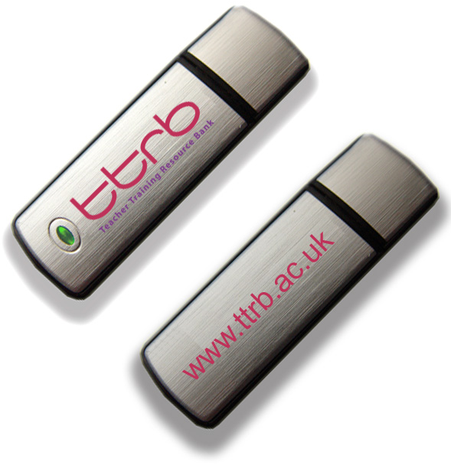  Figure 8: The TTRB USB Pen Drive
Further advice | If you need further advice or guidance on this please e-mail Simon Hughes on sah14@canterbury.ac.uk and every effort will be made to answer your query.

